OUR DORSET INTEGRATED CARE SYSTEM (ICS)
ROLE PROFILE FOR THE DIGITAL PUBLIC ENGAGEMENT GROUP (DPEG) CHAIR

POST DETAILS  Post Title  Directorate  Location  Reports to  Accountable to  Paid Role  Time Commitment  Tenure | Our Dorset ICS Digital Public Engagement Group (DPEG) Chair  Systems Integration Directorate (SID)  Online or at NHS Dorset Headquarters (Vespasian House)  Crystal Dennis, Deputy Director of Digital and Technology  Frances Aviss, Head of Engagement, NHS Dorset  Paid in accordance with national patient voice guidance session rates  2-4 sessions per month (nominal subject to need)  12 months (renewable)

ROLE PURPOSE
- To chair the Our Dorset Digital Public Engagement Group (DPEG)
- To support the DPEG to provide advice, guidance and challenge to inform public engagement across the Our Dorset Integrated Care System for Digital Health Technology.
- To work with and build relationships with DPEG members and partner organisation representatives in creating an environment where honest and constructive views can be shared.
- To represent the views of the DPEG at the PEG (Public Engagement Group) the Integrated Care Partnership and the Communications and Engagement Steering Group.
- To hold the collective view of digital services for the Integrated Care Partnership as one of the two public voices for the group, alongside the chair of PEG.

ROLES AND RESPONSIBILITIES

Introduction

Our Dorset Integrated Care System (ICS) is made of the following partner organisations:

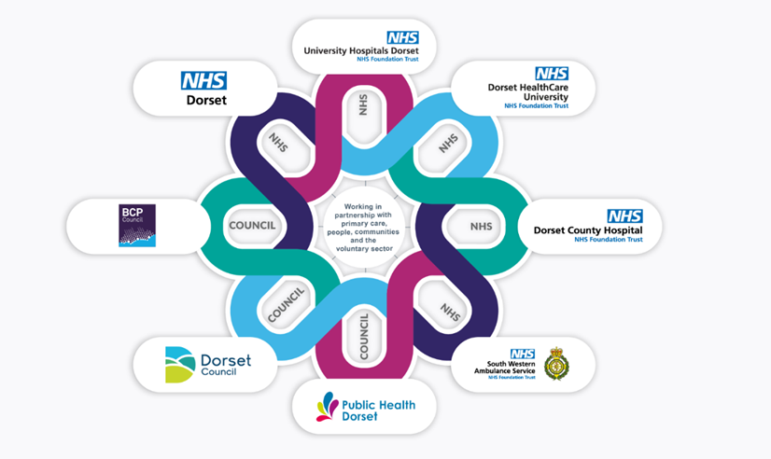

The purpose of the ICS is to bring partner organisations together to:

- improve outcomes in population health and healthcare
- tackle inequalities in outcomes, experience and access
- enhance productivity and value for money
- help the NHS support broader social and economic development.
Strategy – Our Dorset

Partner organisations are committed to placing the views of local people at the heart of Health and Care services, ensuring they are included as equal partners in their design. They will support and empower representatives to enable them to influence and shape service development and provide feedback on existing services.

Our people and communities – NHS Dorset

Meaningful and timely engagement and communications plays a vital role in underpinning service delivery and improvement. It is also evidence based to improve understanding, support, outcomes and experience.

Our Dorset approach is to work in partnership with people and communities, as well as with staff and partner organisations.

Our Dorset is committed to the following 10 principles for working in partnership with people and communities.
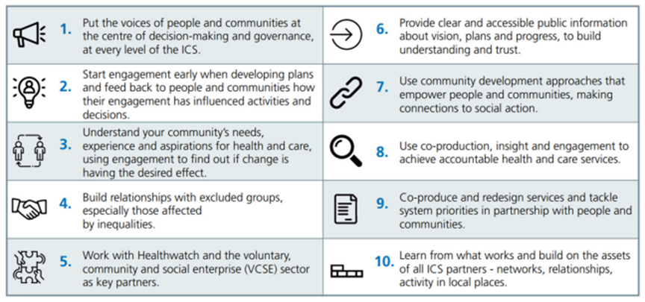

Each partner organisation has independent engagement arrangements. Representatives from each of these organisations sit on the Dorset ICS Engagement Leads Network. This group facilitates system-wide networking and collaborative working, sharing of good practice and the opportunity to minimise duplication. The network reports on its activity and feeds into the ICS Engagement and Communications Steering Group and from there to the People and Culture Committee of NHS Dorset.

In 2017 the Our Dorset Engagement Leads developed an Our Dorset Public Engagement Group (PEG), as one component of system-wide public engagement.

A Digital Public Engagement Group (DPEG) was formed in 2021 in addition to the PEG with a diverse membership of over 20 people.

The Terms of Reference for the DPEG can be read here. Or accessed via the following website Digital Public Engagement Group – Our Dorset.

Role of the DPEG chair:

- To manage DPEG meetings by ensuring:

- Agendas are prepared in advance.
- Appropriate professional input is secured.
- They are kept to time and the focus of the agenda is adhered to.
- All members are given equal opportunity to contribute their views.
- To support the DPEG to review and critique public engagement plans from partner organisations to help ensure that they are appropriate, meaningful and timely and that they are aligned with various stages of progress for each Our Dorset programme
- To support the DPEG to give constructive support and feedback to assist with the development of core materials required to successfully communicate and engage with local people across Our Dorset programmes
- To encourage the DPEG to reflect wider views through their knowledge and experience
- To enable rich and informative conversations with, and feedback from, DPEG members who will have a wealth of experience and expertise from across Dorset’s geography, demography and diversity
- Ensure the DPEG membership remains effective, representative and vibrant in its scrutiny and commentary on the engagement approaches of Dorset’s integrated care system.

Main Contacts

- DPEG members
- NHS Dorset Digital and Engagement representatives
- Partner organisation representatives
- Patient and Public representative groups working with partner organisations
- The VCS Assembly, GP practice patient groups, League of Friends groups, a wide range of community groups, including ethnically diverse communities.

ACCEPTANCE

Signed by – Post Holder: Date:

Signed by – Manager: Date:

