**Driver Diagram Example**

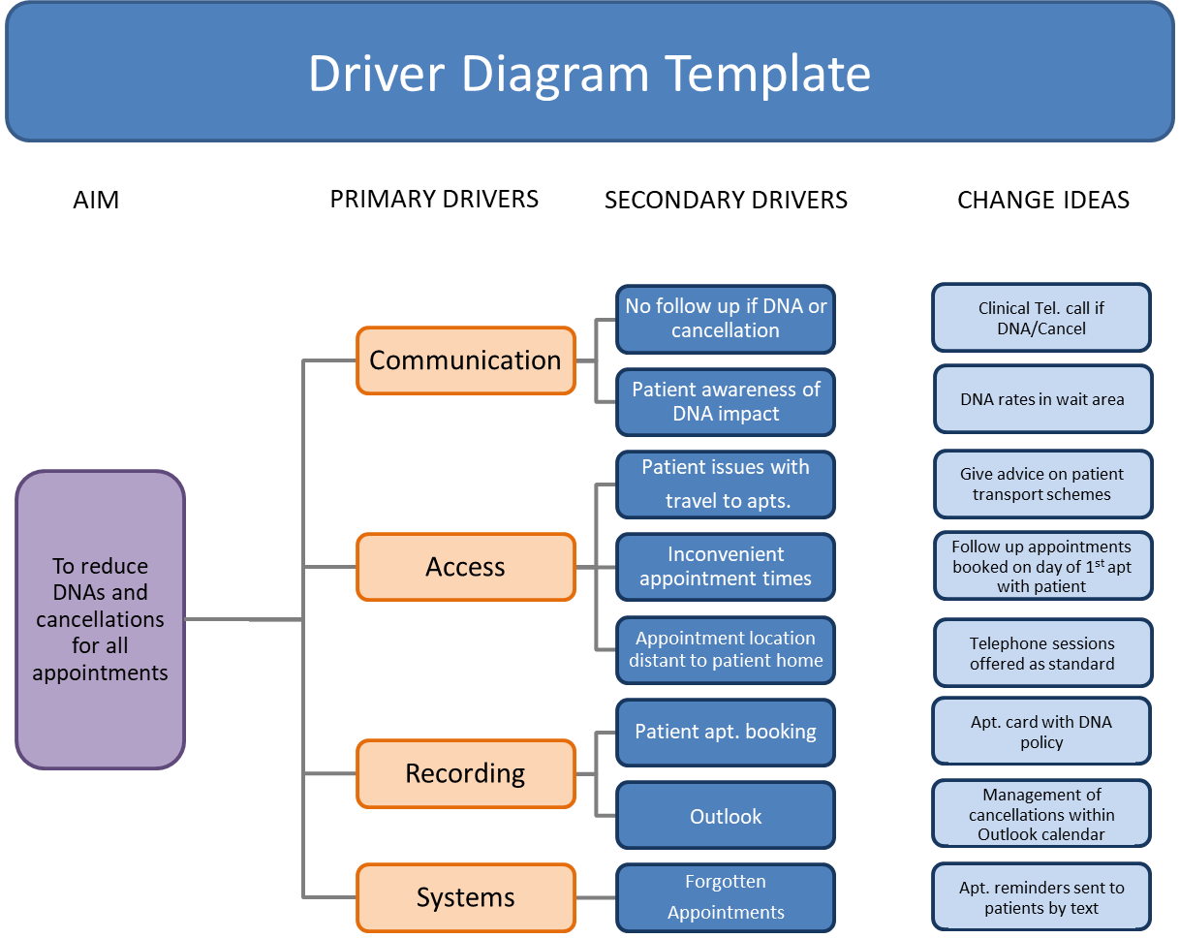

**Driver Diagram Template**

AIM/

CHANGE

X……………………………………………

X

X

X

X

X

X

Primary Drivers

Secondary Drivers

Change Ideas