Guidance on completing a Fishbone Diagram [Layout 1 (england.nhs.uk)](https://aqua.nhs.uk/wp-content/uploads/2023/07/qsir-cause-and-effect-fishbone.pdf)

**Fishbone Diagram Example**

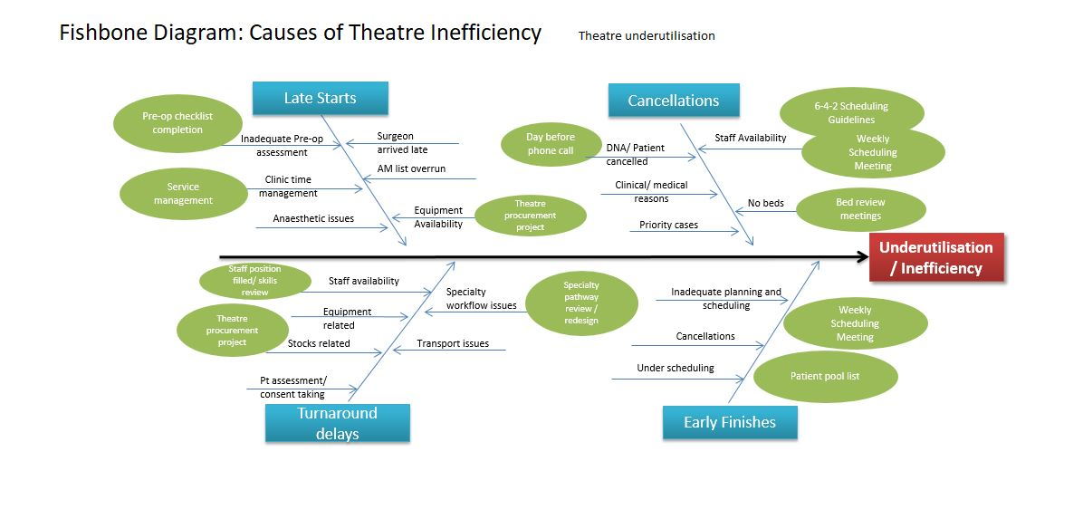

Reasons the problem occurs

**Problem**

**Fishbone Diagram Template**

Reasons the problem occurs

Reasons the problem occurs

Reasons the problem occurs