FULL BUSINESS CASE

Project Details
Project Name: | Project is temporary in nature, with a specific start and end date, and created to deliver one or more specific products.
Programme Name: | Complete programme name if this project forms part of a larger programme of work (a group of related projects managed in a coordinated way to obtain benefits not available from managing them individually).
Lead Organisation: | Which organisation is accountable for the delivery of the programme or project?
Senior Responsible Owner: | Who has overall accountability for ensuring the programme or project meets its objectives and delivers the expected benefits?
Responsible Finance Officer: | Which Finance Officer have you consulted with regarding this project?
Clinical Sponsor: | If the programme or project has clinical elements, which clinical sponsor will oversee the clinical legislative aspects and guidance?

Document Control
Author(s): | Date: | Version: | Summary of Changes: | Approved by:

To be completed by Portfolio Management Office:
Celoxis Reference Number | To be completed by the Portfolio Management Office
Portfolio: | To be completed by the Portfolio Management Office

Executive Summary

Strategic Case

Economic Case

Commercial Case

Financial Case

Management Case

Strategic Case
The purpose of the Strategic Case in the FBC is to revisit and confirm the case for change for the programme or project, and to demonstrate how it aligns with the strategic objectives of the host organisation. It also demonstrates how the work relates to other programmes and projects within the organisation’s portfolio.
To do this effectively, we will need to evidence an up-to-date organisational business strategy that references all relevant local, regional and national policies and targets. The objectives must also be clearly established, and should be ‘SMART’ – Specific, Measurable, Achievable, Realistic and Timebound.
Making the case for change requires a clear understanding of the organisation’s existing arrangements (1.5), including:
- Business as Usual operations (BAU)
- The Business need (related problems and opportunities)
- The potential Scope of the project (what the organisation needs to be delivered)
- The potential Benefits, Risks, Constraints and Dependencies.
The strategic case needs to show the organisation’s business needs have been well researched, which will help us to write a convincing case and justifies the requested funding to achieve the project’s objectives and benefits, as well as documenting the associated risks.

Introduction – The Case for Change

Why is the change required? This section should provide a compelling reason for undertaking this project or programme. Templates such as 5 Whys, Driver and Fishbone Diagrams can assist in identifying the root cause to support the case for change.

<Insert text here>

Organisational Overview

Who the lead organisation for this programme/project? What key stakeholders are involved, either internally (within your own organisation) or externally (outside of it)? What is their relationship to this programme/project?
Has a new partnership been created to support this work?

<Insert text here>

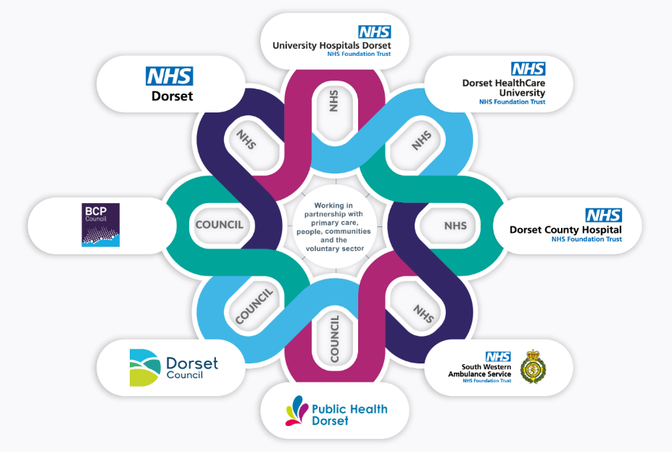
The Dorset Integrated Care System (ICS) is the partnership of Dorset’s four NHS organisations, two local authorities and voluntary sector organisations. We take collective responsibility for planning services, improving health, and reducing inequalities across Dorset, serving a population of over 800,000 people.
Figure 1 - Dorset ICS partners
Dorset has significant disparities in health outcomes and general wellbeing. The population is generally older than the national average, with a high percentage of residents over the age of 65. However, 25% of the population (202,972) are aged 0-24. There are 11 areas in Dorset, including Weymouth, Portland, and Boscombe, which have been named as some of the poorest in the country. 46% of Dorset's population lives in rural areas, many of which are deprived of access to housing, digital connectivity, and other essential services.
This project is being driven by needs identified across Dorset ICS, with leadership from NHS Dorset ICB on behalf of the system.
- NHS Dorset Integrated Care Board (ICB)
NHS Dorset Integrated Care Board (ICB) is the statutory body responsible for planning to meet the health care needs of people and communities in Dorset. Formally in existence since July 2022, this organisation is the successor to NHS Dorset Clinical Commissioning Group.

National and Regional Drivers
What are the national, regional and local priorities, strategies and policies which support your case for change? Has the government mandated the change? Have there been studies which support the need for intervention? How does this change align to the Five Pillars and the ambition in the Dorset Integrated Care System?

<Insert text here>

Local Drivers
What are the key local priorities and strategies which support your case for change? What is Dorset trying to achieve? How does this programme/project align with the lead organisation’s and Dorset ICS’s strategic objectives?

<Insert text here>

Existing Arrangements
What is the organisation or Dorset ICS partners currently doing in this area? Briefly describe how things work now. What resources or assets are in place? Is it still fit for purpose? How much is currently being spent on this arrangement?

<Insert text here>

Business Needs
What does the business/organisation need to do to fix the problem(s)? What data do you have to support this?
Is there any indication on how much it will cost?

<Insert text here>

Investment Objectives
An objective should be a SMART (Specific Measurable Achievable Realistic Timebound) goal or outcome the project is designed to accomplish and provides direction and focus for all project activities. Objectives for public services are often considered within these areas: Effectiveness (improve the quality), Efficiency (improve the delivery), Economy (reduce costs), Compliance (meet statutory, regulatory or organisational requirements and best practice) and Replacement (re-procure to avert service failure.)

Table X – Investment Objectives
Ref | Investment Objectives
IO1
IO2
IO3
IO4

Scope
Scope describes the inputs and outputs of the project and defines its boundaries and limitations. This can include funding, resources etc and should include any constraints or assumptions made. NB: It is important to ascertain what it is not aiming to achieve or what areas it will not include, as well as specifically stating what you will do.

<Insert text here>

Benefits
A benefit is defined as “the measurable improvement resulting from an outcome, perceived as an advantage by at least one stakeholder group”.
There are four distinct categories of benefits:
- Cash-releasing (money will be saved or goes back into the bank)
- Non-cash releasing (money will be saved, but it will be spent elsewhere)
- Societal (where the wider benefit can be monetised)
- Quantitative (can be measured but not monetised).
What key, measurable benefits will be realised following the implementation / delivery of the project?
Any benefits you identify need to be baselined to make them measurable.
Start a Benefits Register using this template.

<Insert text here>

Risks
Risk - A future uncertain event or condition that will have a positive or negative effect on a programme's objectives. The events that have potential positive consequences for the programme are known as opportunities.
Issue - Events or conditions that are occurring with negative consequences for the programme. They may arise from identified risks or previously unidentified events.
- We recommend describing risks using these three clauses:
  - The cause or existing condition.
    - “If…”
  - The risk event.
    - “Then…”
  - The Impact/Effect.
    - “So…”
<Insert text here>

Start a Risk, Assumptions, Issues and Dependencies log using this template.

Constraints
A constraint is an external condition in which the project must be delivered, over which the project team has little or no control. Have any dates been mandated? What are the legal limitations? What impact might the constraints have on successful delivery?
<Insert text here>

Use a Risk, Assumptions, Issues and Dependencies log for the detail.

Dependencies
What factors, or other projects, does this project rely on to ensure successful delivery? Does anything need to happen before work starts on this project? You need to think about start and end dates of other projects and key milestones. The earlier you think about this, the better If funding has been promised, but not guaranteed, it may create a dependency on the scope.
<Insert text here>

Use a Risk, Assumptions, Issues and Dependencies log for the detail.

Conclusion

<Insert text here>

Economic Case
The Economic Case in the FBC confirms that the options outlined in the Outline Business Case (OBC) are still relevant, including revising the cost of risk and value of benefits and that the preferred option still delivers the Best Possible Value for the organisation, including wider social and environmental benefits. Including evaluation and running economic evaluation from the Best and Final Offer (BAFOs).

Introduction
Give some context on how the options for delivery have been identified/appraised (i.e., describe how you got the team together to talk about the options). The Economic Case will focus on the main options available for delivering the required goods/services, with a view to formulating the preferred option.

<Insert text here>

Critical Success Factors
The Critical Success Factors are the attributes essential to the successful delivery of the programme or project, against which the available options will be assessed. Give some context around how each Critical Success Factor relates to your project.

Strategic Alignment | The project must align with the national (NHSE) guidance and local (Dorset ICS) priorities.
Business Need | The project must meet the agreed investment objectives, the related Dorset demographic needs, and the service requirements; with the requirements for significant public engagement.
Safe & Sustainable Service | The project must ensure patient safety, i.e., that patients do not come to harm because of the way services are delivered, and the project must operate at a financially sustainable level for the foreseeable future.
Best Possible Value | The project needs to offer financial, productivity, quality and system benefits which outweigh the investment and appropriate management structures to ensure benefits are realised.
Capacity and Capability | The preferred option must meet the capacity requirements to meet demand, and capability of the staff to manage the expected conditions.
Deliverability | The project needs to be deliverable and able to the service objectives within the required timeframe.
Affordability | The project will be funded using the available sources of finance. Additional investment will be considered in line with wider system benefits.

<Insert text here>

Long-list appraisal
The long-list is compiled of all options which could potentially deliver the critical success factors and investment objectives for the project. Options are scored against five dimensions (below):

No | Dimension | Description
1 | Service Scope | What will the option potentially cover? What are the business needs, service requirements and the required scale of organisational change?
2 | Service Solution | How will the preferred service scope be delivered? This might mean considering available technology or best practice methodologies.
3 | Service Delivery | Who will deliver the preferred scope and solution? It could be internal resources, external providers, or alliances with strategic partners.
4 | Implementation | When will preferred scope, solution and delivery arrangements be implemented? What deadlines, dependencies or constraints are attributed to the options? How long are the phases (or tranches)?
5 | Funding | What funding is required to enable the successful delivery of the preferred scope, solution, delivery and implementation options? This could be public or privately funded, or a mixture of both. Is it capital or revenue?

<Insert text here>

Short-list Appraisal
Based on the critical success factors and investment objectives, which options have been shortlisted as potentials? This section should include at least four potentials:
- A “Do nothing” option.
- A “Do the minimum” option.
- A “Do something” option.
- A “Do maximum” option.

<Insert text here>

Preferred Option
Based on the results of the short-listing process, we will be able to identify the Preferred Option.
Give a summary of the justification for the decision.

<Insert text here>

Conclusion

<Insert text here>

Commercial Case
The purpose of the Commercial Case in the FBC is to confirm the procurement process and the negotiated deal with the preferred provider, including the contractual arrangements.

Introduction
The purpose of the Commercial Case is to demonstrate the viability of procuring the Preferred Option, as well as how it will be achieved; it will need to show that the market has been well researched, and that a procurement route can be achieved feasibly.

<Insert text here>

Service Requirements
The Service Requirements are the high-level components for the delivery of the project; this could be anything from office space to digital licences. What are the timescales you will need to have requirements delivered in?

<Insert text here>

Commercial Strategy
How would you work with partners to deliver the product and make it commercially viable?
Are you generating any income? Most of our services do not generate any income because we are a public service.

<Insert text here>

Procurement Strategy
The Procurement Strategy will outline how services will be gathered for the project. Can the market deliver your service requirements? Is there a framework you can use to choose a provider? Will you need to go to tender, or go “off framework”, to find a suitable provider for the goods or services?

<Insert text here>

Procurement Plan and Proposed Implementation Timescales
The project plan for procurement of key outputs and activities should be outlined here or attached as an appendix. For example, if you will be running a formal tender process, indicate when you expect the process to start and finish.

<Insert text here>

Conclusion

<Insert text here>

Financial Case
The Financial Case in the FBC is to detail the financial consequence including reviewing the overall affordability of the negotiated deal, over the lifespan of the contract.

Introduction
The Financial Case demonstrates the affordability and funding for the preferred option, along with evidence of support from key stakeholders.

<Insert text here>

Overall Affordability and Funding
How much is the programme / project likely to cost the organisation? How will the funds be distributed over its duration What are the assumptions you have made to generate your indicative costs?

 | Year 0 | Year 1 | Year 2 | Year 3 | Total
Preferred Option
Capital
Revenue
Total
Funded by
Existing
Additional
Total

<Insert text here>

Capital and Revenue Requirements
This section should set out the capital and revenue requirements of the preferred option over its lifecycle, or the contract period. Include a statement that the organisation has sufficient income to meet the ongoing costs.
Compare the figure with the original constraints for the programme or project – is there a difference?

<Insert text here>

Statements of Support from Stakeholders
Which organisations or key stakeholders have committed support to this programme or project? Can they provide you with signed letters of support, either from Chief Executives or senior managers?

<Insert text here>

Conclusion

<Insert text here>

Management Case
The Management Case in the FBC finalises the following:
- Project management arrangements and plans
- Change management arrangements and plans
- Benefit realisation arrangements and plans
- Risk management arrangements and plans
- Contract management arrangement and plans
- Post-project Evaluation arrangements and plans

Introduction
Explain to decision makers how the programme/project will be ‘achievable’. Detail how the actions, roles, responsibilities and strategies will facilitate successful delivery. Is the organisation ready, or able to, achieve the deliverables you have set out?

<Insert text here>

Key Stakeholders

<Insert text here>

Programme/Project Management Arrangements
What key roles will be involved in this project and what are their responsibilities? What will the governance structure for the project be? The table below has been included to help you answer these questions. Consider the use of a RACI to help you document the roles and responsibilities of the project team.

Role | Responsibility | Organisation/Individual
Host Organisation | Responsible and accountable for receiving and ensuring the delivery of funding associated with the programme or project.
Lead Organisation | Accountable for the project's success and is responsible for ensuring that the project is completed on time, within budget, and according to the specified quality standards.
Senior Responsible Owner | Have sufficient seniority to provide the project with the necessary support and resources, make key decisions, and act as a bridge between the project team and senior management. Should have sufficient capacity to support the project as they are accountable for ensuring the programme or project meets its objectives and delivers the projected benefits.
Programme / Project Manager | Responsible for the day to day running of the project, ensuring work is completed in a timely manner and managing cost, time and quality for a successful outcome.
Benefits Manager | Develops and maintains the benefits management approach and provides oversight and assurance that the programme is on track to deliver the expected benefits.
Change Manager | Responsible for facilitating and managing changes and their impact, both to the baseline scope of the project and to stakeholders affected by the change

Programme and Project Methodology (PPM) Strategy
The implementation strategy of most organisations for the successful delivery of schemes is to embrace the principles of programme and project management and to adopt a methodology for both, based on proven standards and quality management.

<Insert text here>

Governance Arrangements
Produce a diagram which shows:
- Organisational and Project Structure
- Reporting arrangements
- Governance arrangements
- Key roles and responsibilities
- Appointed personnel and any vacancies

A Terms of Reference template may assist in identifying all the areas to consider.

<Insert text here>

Programme/Project Management Plan
What are the key timescales for delivery? How long will the expected phases or tranches last? What work will be undertaken during each stage?

<Insert text here>

Use of Specialist Advisors
Advisors
Specialist Area | Special Advisor / Description of Support

Benefits Management
What methodology will be used to manage benefits? Establish a Benefits Register to track and monitor expected benefits. Attach the benefits register as an appendix. The responsibility for benefits realisation lies with the SRO for the project, who must ensure that delivery arrangements are outlined within the Business Case.

<Insert text here>

Risk Management
What methodology will be used to manage risk? In Dorset, we use the National Patient Safety Agency methodology to manage and score risks. Establish a Risk Register (or a RAID log) and reference it as an Appendix.

<Insert text here>

Change Management
What methodology will be used to manage change? Who will be responsible for ensuring change is managed and implemented successfully? How will key changes to the baseline scope of the project be recorded and monitored? How will you manage your stakeholders? How will you communicate with them? How will you engage with them?

<Insert text here>

Gateway Review Arrangements
What reporting periods are planned for the project? How often will reporting occur? Who will receive the key updates on milestones? How will slippage (missing of deadlines) be monitored? What happens once this business case has been signed off? What groups/boards are involved in the decision-making process? What group/individual has the authority to cease the programme/project if necessary?

<Insert text here>

Conclusion

<Insert text here>

